**Book 3**

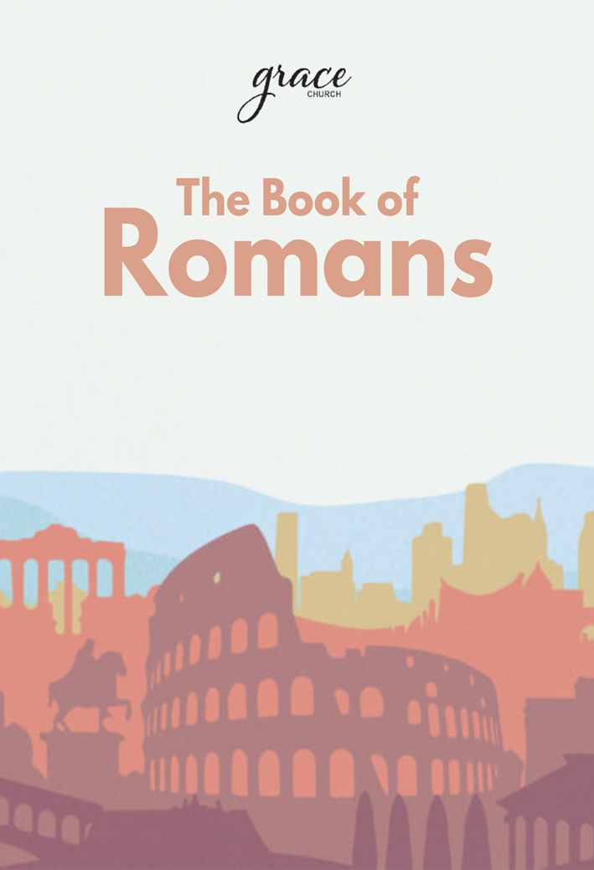

**The Book of Romans**

**Part 3 of 3**

This is the third of three study guides on Romans chapters 1-8. Because Romans is set up to make points that systematically build on each other, it would be helpful to start with the first study guide first.

The book of Romans is one of the longest and most significant things written by the Apostle Paul, formerly known as Saul of Tarsus. Paul was a Jewish rabbi belonging to a group called the Pharisees, and he passionately devoted his life to observing the Torah of Moses and the traditions of Israel. He viewed Jesus and his followers as a threat to these traditions, so he persecuted them. His life was changed, however, when he had a radical encounter with the risen Jesus himself. Paul was commissioned to become an apostle for Jesus, an official representative to the world of non-Jewish people (or Gentiles).

As part of this new vocation, he started going by his Roman name, Paul, and he traveled about the ancient Roman empire telling people about the risen King Jesus. These new converts would form communities called churches, and Paul would occasionally write letters to these churches to foster their faith, address specific problems, or answer questions. The book of Romans is one of these letters written later in his career.

In this series guide, we want to help you grow in your confidence as a student of the Bible. We have a couple of ways we aim to meet this goal. One way is by providing guiding questions that help as you read the letter of Romans. Each week will be structured similarly. There will be five sessions for each week:

* **Discovery**: Day 1 will feature questions that prompt you to read the focus passage/chapter and carefully observe what the passage is saying.
* **Deeper Look**: On days 2-4, the questions and activities will invite you to re-read the passage, taking a deeper look at the

cultural connections and theological topics of the verses and interpreting the applicable meanings of the passage.

* **Do It**: The questions on Day 5 will focus on reflection and challenge us to discern how the Lord wants us to apply the teaching of the passage to our lives.

Our prayer is that this study guide would provide on-ramps for you to enter into reading Romans, tools to help you understand the book, and encouragement to apply what you understand by living it out in your life!

References

1 Bible Study Fellowship, (2017). “Romans Introduction Lesson,” p. 2. San Antonio: BSF International.

2 Godet, F. L. (1977). Commentary on Romans. Grand Rapids: Kregel Publications. (As cited in “Romans Introduction Lesson”).

3 Luther, M. (1976). Commentary on Romans. P. xiii. Grand Rapids: Kregel Publications. (As cited in “Romans Introduction Lesson”).

**Week 1:**

**Living by the Spirit as Adopted Children of the King**

**Key verses: Romans 8:1-2, 8:15, and 8:22-23**

**Romans 8:1-2 -** *Therefore, there is now no condemnation for those who are in Christ Jesus, because through Christ Jesus the law of the Spirit who gives life has set you free from the law of sin and death.*

**Romans 8:15 -** *The Spirit you received does not make you slaves, so that you live in fear again; rather, the Spirit you received brought about your adoption to sonship. And by him we cry, “Abba, Father.”*

**Romans 8:22-23 -** *We know that the whole creation has been groaning as in the pains of childbirth right up to the present time. Not only so, but we ourselves, who have the first fruits of the Spirit, groan inwardly as we wait eagerly for our adoption to sonship, the redemption of our bodies.*

**Day 1: Discover Romans 8:1-11**

Over the course of this study of Romans, we have practiced a method of Bible study that practices a first reading of a passage as objective observers, refraining from interpreting the passage at first. We invite you to step into that position again as you read the passage.

**Read Romans 8:1-11.** As you read, attend to the Holy Spirit’s leading as He guides you to words and phrases that resonate with you. Record your observations in the chart below.

|  |  |
| --- | --- |
| *Verses* | *My observations* |
| 8: 1-4 |  |
| 8:5-8 |  |
| 8:9-11 |  |

**Observe:**

What recurring words and thematic patterns do you notice in verses 1-11?

**Day 2: Deeper Look – Romans 8:1-11**

Sometimes “flesh” is used in the New Testament to just literally refer to physical human tissue (2 John 1:7). In our second Romans series study guide, it was noted that in the book of Romans and throughout the New Testament, the term “flesh” also often refers in context to a handful of interconnected spiritual themes and ideas.

These interconnected themes include our old “Adam” sin nature apart from God (from Romans 5), or our attempts to rely on our own self-righteousness apart from faith (Romans 6-7). In such verses, the idea of being “in/from the flesh” is the opposite of being “in/of/by the Spirit.”

**Read the following passages** and make note of recurring themes and interconnected ideas shared across these verses.Also note any specific points you see that might be unique or emphasized in one passage over the others.

**Galatians 5:13-24**

**Ephesians 2:1-5**

**Philippians 3:1-11**

**Go back through your notes** from yesterday to observe Romans 8:1-13. Re-read that passage again, specifically looking for references to “the flesh.”

**Pray and meditate** on this Romans passage and the other verses. What new insights do you have into the meaning of these verses. What does the tension between “the flesh” and “the Spirit” look like in your own life?

**Day 3: Discover Romans 8:12-30**

Over the course of this study of Romans, we have practiced a method of Bible Study that practices a first reading of a passage as objective observers, refraining from interpreting the passage at first. We invite you to step into that position again as you read the passage.

**Read Romans 8:14-30.** As you read, attend to the Holy Spirit’s leading as He guides you to words and phrases that resonate with you. Record your observations in the chart below.

|  |  |
| --- | --- |
| *Verses* | *My observations* |
| 8:12-13 |  |
| 8:14-17 |  |
| 8:18-23 |  |
| 8:24-25 |  |
| 8:26-27 |  |
| 8:28-30 |  |

**Observe:**

What recurring words and thematic patterns do you notice in verses 12-30?

**Day 4: Deeper Look – Romans 8:12-17**

**Pray and meditate** on the idea of being adopted as children of God and co-heirs with Christ.

Consider the idea of being a former slave adopted into a royal family. What significance does this status have for us beyond merely having Christ’s sacrifice fulfill God’s justice toward our sin?

What assurance and security does that truth about our spiritual identity as a sibling of Christ bring into the suffering described in verses 18-30?

**Day 5: Do it! – Battle of the Minds**

Compare and contrast the “the law of my mind” in Romans 7:23 with the “law of the Spirit” in Romans 8:2. What other parallel themes can you find in these two verses?

**Read the following verses:**

**Romans 12:2**

**2 Corinthians 10:5**

**Ephesians 4:22-24**

**Hebrews 10:14-18**

**Re-read Romans 8:5-8.**

When your mind turns from Christ, what does your mental battlefield look like, and what thoughts need to be taken captive as prisoners of this spiritual war of your mind?

Think about your own personality. Some of us are more on guard against our tendency toward anger, fear, apathy, self-centeredness, bitter unforgiveness, lust, greed, or simply a lack of love and compassion. Where are your vulnerabilities? How does this “spiritual mind game” tend to play out for you?

This mental battle can be poorly fought under our own strength and effort or fought victoriously through faith and a reliance on the Holy Spirit. Referring back to the principles in the first seven chapters, what does it look like for you to fight such battles by faith and the Spirit instead of our own efforts and our flesh nature?

Think of ways that taking advantage God’s provisions for you of scripture, prayer, fellowship, and ministry have provided spiritual clarity in your mind and realigned you with the heart of Christ. What steps can you make to take better advantage in the future?

**Pray** to ask God to reveal to you how and where God has over time transformed your ways of thinking as you mature in your new identity in Christ in your sanctification process.

**Week 2:**

**Inseparable from Our Loving Heavenly Father**

**Key verses: Romans 8:38-39**

**Romans 8:38-39 -** *For I am convinced that neither death nor life, neither angels nor demons, neither the present nor the future, nor any powers, neither height nor depth, nor anything else in all creation, will be able to separate us from the love of God that is in Christ Jesus our Lord.*

**Day 1: Discover Romans 8:31-39**

**Read Romans 8:31-39.** As you read, attend to the Holy Spirit’s leading as He guides you to words and phrases that resonate with you. Record your observations in the chart below.

|  |  |
| --- | --- |
| *Verses* | *My observations* |
| 8: 31-34 |  |
| 8:35-37 |  |
| 8:38-39 |  |

**Observe:**

What are “these things” that Paul refers to in verse 31?

What is implied in the second half of verse 31?

How is God’s graciousness defined in verse 32?

In verse 33, what is the significance that God is the ultimate judge of mankind?

**Take apart the phrases in verse 34:**

Who condemns?

Where is Jesus now located?

What is Jesus now doing on our behalf?

What can separate us from the love of Christ? (verses 35-39)

**Day 2: Deeper Look – Romans 8:31-34**

**Read Isaiah 50:7-9.**

**Read Exodus 34:6-7**. How does the phrase “Sovereign LORD (Yahweh)” gain more depth of meaning considering how God defines Himself in that passage?

How would you describe the relationship between the Sovereign LORD and his servant in this passage?

Who may this passage be about?

How does Christ’s victory guarantee the victory of those who belong to Him?

In what ways do you see the Isaiah passage reflected in Romans 8:31-34?

**Read Psalm 118:5-7.**

How do these verses amplify or connect or explain further Romans 8:31-34?

**Pray** for the Lord to deepen your knowledge of His love through experiences you have today as you trust him to be your Helper, Defender, Savior, and Protector.

**Day 3: Deeper Look – Romans 8:35-37**

**Read I Corinthians 4:8-16.**

What type of persecution does Paul describe having experienced?

What is dangerous when Christian’s fear persecution and suffering?

What does Roman’s 8:35-37 say about fearing suffering?

How may victory in Jesus look differently than victory as our culture describes it?

**Pray** for the Lord to give you spiritual wisdom and understanding to appreciate the opportunities to suffer and to become more like Christ as we endure suffering. Ask that He may be victorious in and through us.

**Day 4: Deeper Look – Romans 8:38-39**

**Read I Corinthians 3:18-23.**

When we belong to the kingdom of God, we no longer succumb to the foolishness of the ages. In this passage, Paul claims, “all things are yours” and “you are of Christ and of God.”

What things does this passage claim belong to believers?

How does this passage relate to Romans 8:38-39. If we have all things, then what can separate us from God?

Of the things Paul lists as concerns that we may be tempted to believe separate us from God’s love, which do you struggle with the most:

death and life **|** angels or demons **|** fears for today **|** worries for tomorrow **|** power of hell **|** sky above **|** earth below

How may this confidence in God’s love compel you to live by faith and to engage in hopeful obedience this week?

**Day 5: Do it! – Romans 8:31-37**

**Reread this passage.**

How can you apply the truth of being forever secure in God’s love to your life now?

What does it mean to be “more than a conqueror” to you? How can you activate this truth in your life?

We cannot be condemned because of Christ’s death and resurrection and as children of God (John 1:11-13; Acts 3:25; Romans 8:14-23; Romans 9:4-26) we are deeply loved. How does this knowledge of your security in God through Christ affect you? How will this help you live differently?

*Used with permission from*

629 Wesleyan Ave. Barberton, OH, 44203

234.417.0002 | barberton@graceohio.org